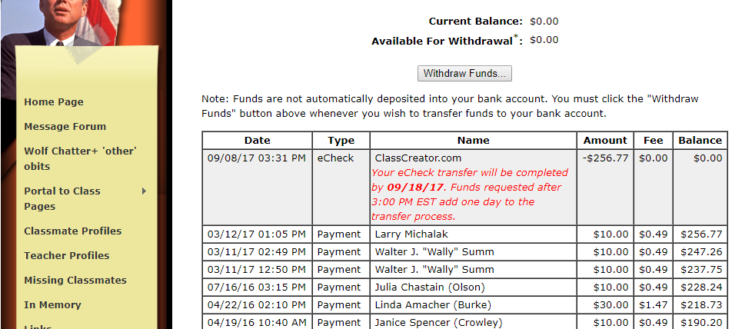

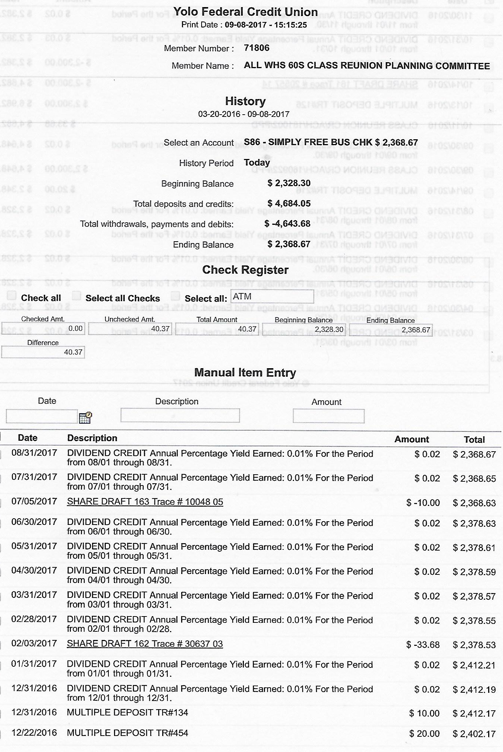
8 September 2017 Reconciliation
Previous balance on 30 Sept 2016 was $4876.68, of which $2300 was payable to Class of 66. So balance really $2576.68 (see 9/8/2016 reconciliation).
Sept 8, 2017 statements show $2368.67 in YFCU and $256.77 being moved from Class Creator to YFCU. That gives a current total of $2625.44.
The difference is $48.76. which is 2 Memory Bks at $10 each cash, and 3 at net $9.51 each thru website ($10 price less a 4.9% fee). The memory books netted $48.53 and there was $0.23 in dividends, totaling the $48.76 gain during the period. All Memory Books sold. v/r GWegener
(Have one outstanding check for $110 for hosted lunch 31 Aug for WHS60s planning group, which leaves $2515.44).

