Follow the money…
At the Planning Committee wrap-up meeting Oct 3rd, the Executive Committee recommended that $200 from the proceeds of the reunion be given back to each class, as seed money for their next function. Additionally, they recommended that $10,000 from the proceeds of the reunion be presented to the Woodland Schools Foundation for use at their discretion at the three Woodland High Schools, in part as a thank you for their volunteer support during the reunion event, and in the spirit of ‘giving back’ to the high school(s) as a thank you for our “high school experience”. (This would leave $2000 plus ‘seed money’ for the next WHS60s event.)
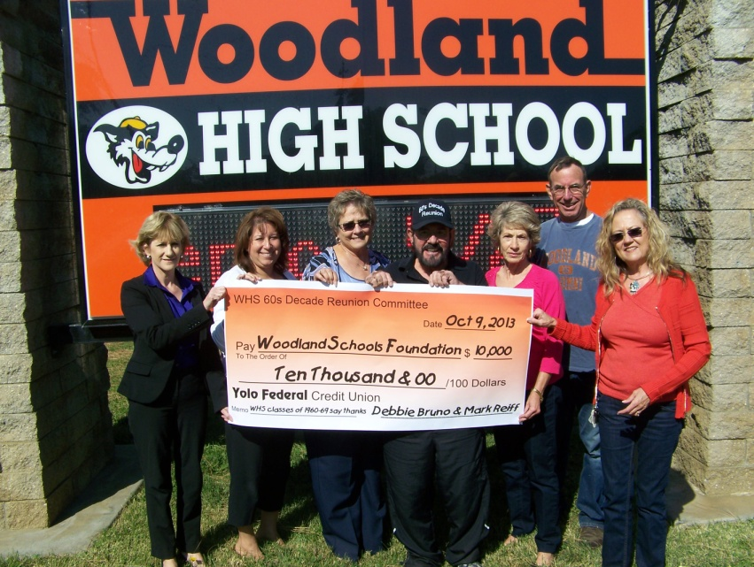
Based on the concurrence of the Planning Committee members present, checks were distributed as follows:

Class of 60, made out to Class of 1960, mailed to Joan Lucchesi, 10/11, cleared bank 10/18.
Class of 61: made out to 'Class of 61', to Carol Wright, 10/7, cleared bank 10/17.
Class of 62, made out to Yolo Hospice from class of 1962, and sent to Bev Harris, (#148) 10/7, cleared bank 10/17.
Class of 63, made out to Class of 1963, mailed to Lynnel Pollock, 10/10, cleared bank (pending).
Class of 64, made out to Class of ’64, given to Eldon Larson, 10/9, cleared bank 10/16.
Class of 65, made out to Class of 65, mailed to Carol Connely 10/11, cleared bank (pending).
Class of 66, made out to /deposited in Class of ’66 account in WestAmerica Bank, Sac by Gary Wegener 10/8,
Class of 67 made out to "Class of 1967," mailed to Mike Grissom, 10/7, cleared bank 10/16.
Class of 68 Bibbet Matter, made out to Class of 68, 845 Wildwood Way, 95695 10/9, cleared bank (pending).
Class of 69, made out to Class of 69, mailed to Frankie Lopez 10/10, cleared bank (pending).
v/r Gary Wegener

